

# COLLEGE OF ENGINEERING & BUILT ENVIRONMENT

# SCHOOL OF ELECTRICAL AND ELECTRONIC ENGINEERING

# COMP 4604 GUI Design & DB Connectivity DT080/B/4

# Online Sports Utility Shop User Manual

Submitted by

Leonard Benny, Jonathan Kaniki and Hassan Handal

Lecturer

Lejla Rovcanin

# System Description:

This application is designed for the sports utility shop and will maintain all the sport items inside. There are multiple shop keepers who will manage this application.

# Shop Keepers can:

1. Add Items
2. View Items
3. Update Items
4. Add Customer
5. Update Customer
6. Check Overdues
7. Check account Status

# Customer Can:

1. View Shop Items
2. Purchase Item
3. Rent Item
4. Return Item
5. Check account Status

# App layout, Customer view:

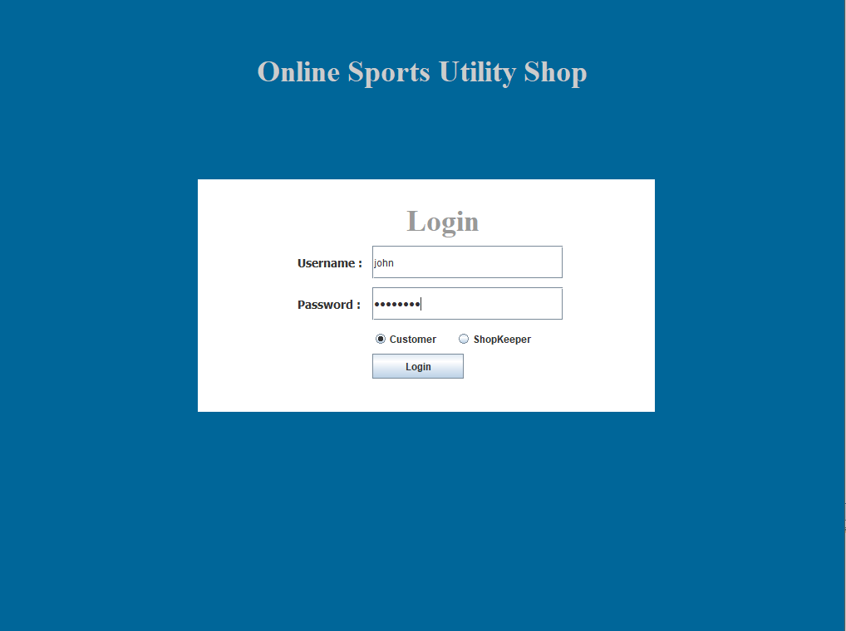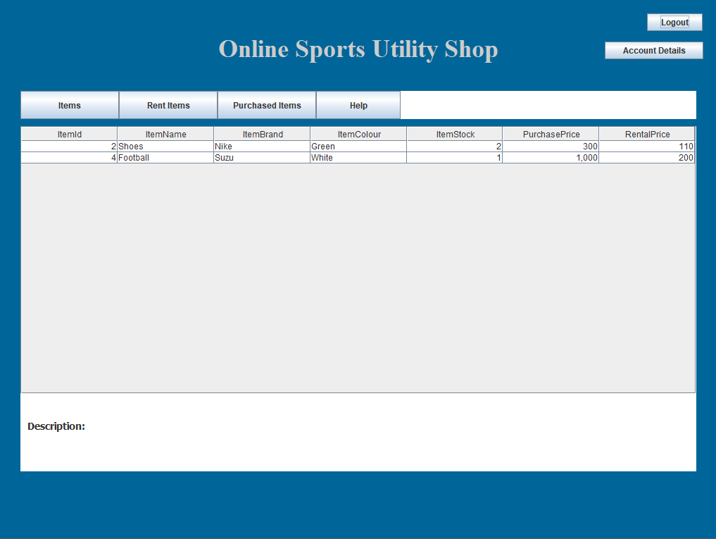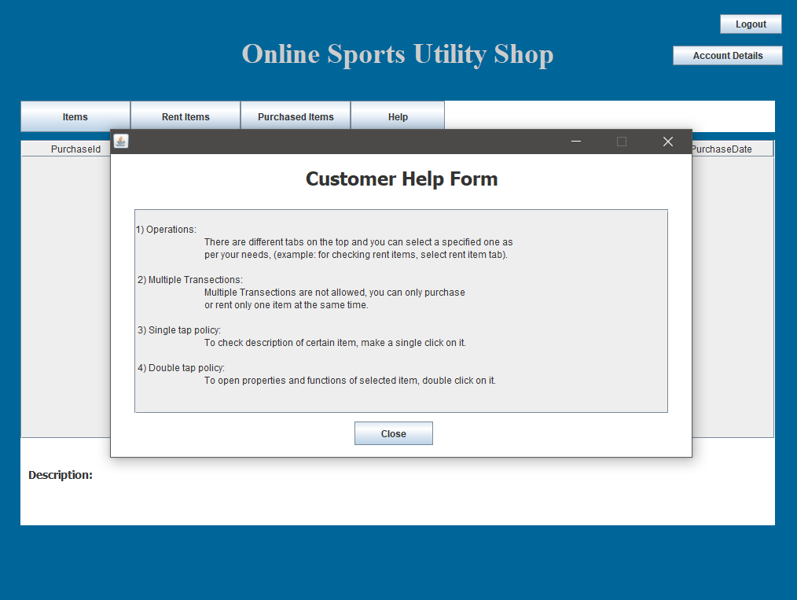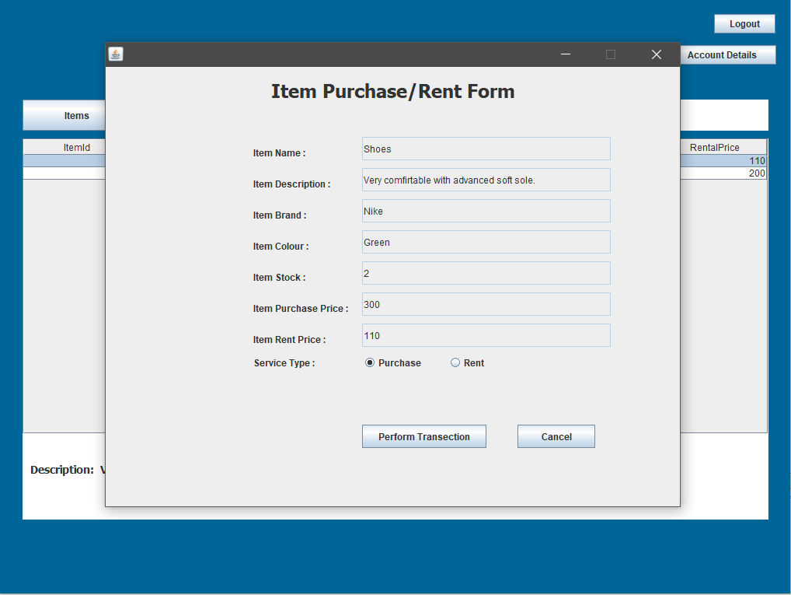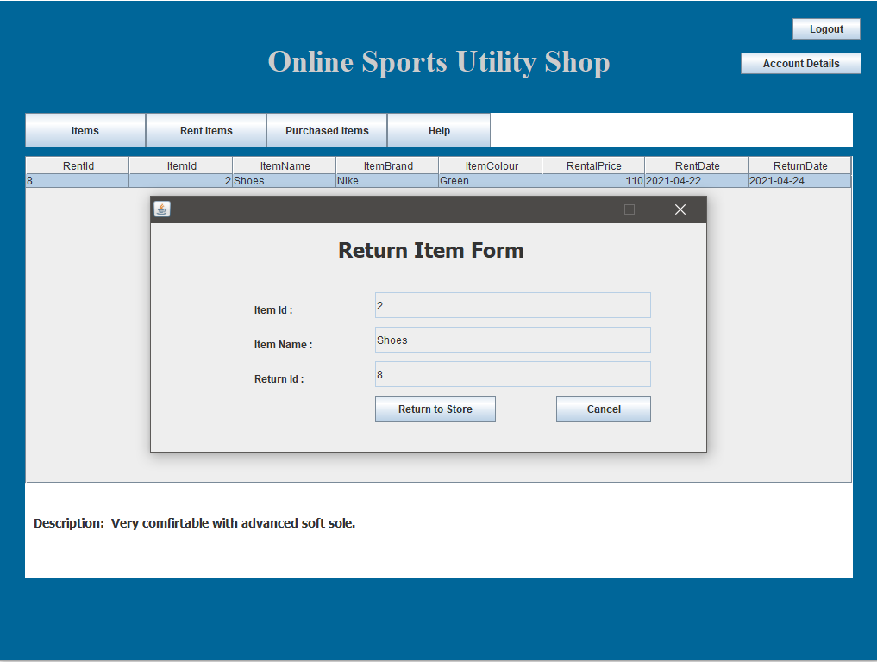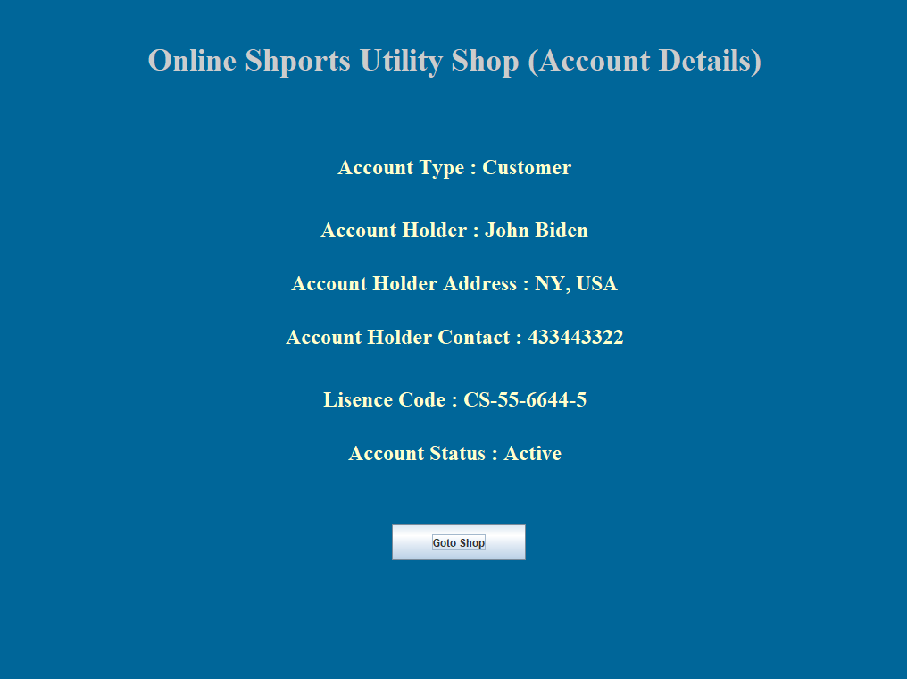

# App layout, Shop Keeper view:

